A000-MEX-Mixtec-Xipe Totec-Jade-Classic Period-700-900 CE

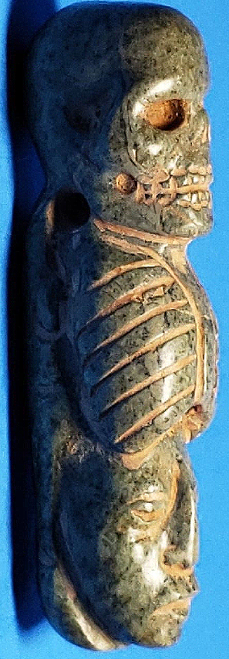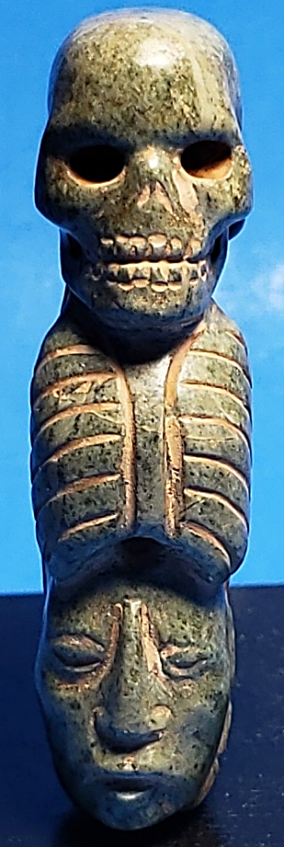 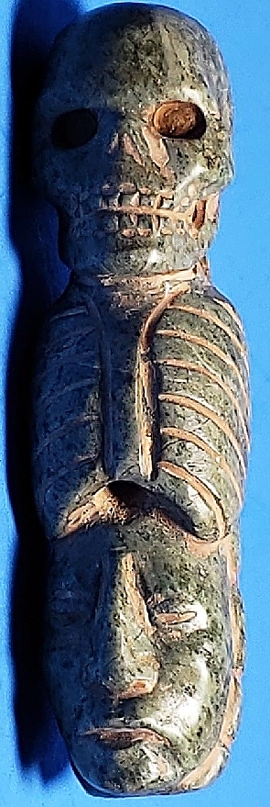

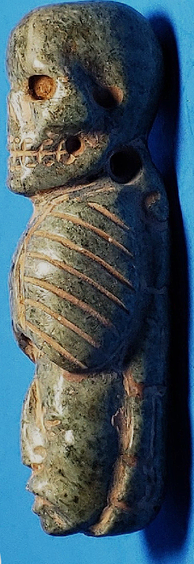 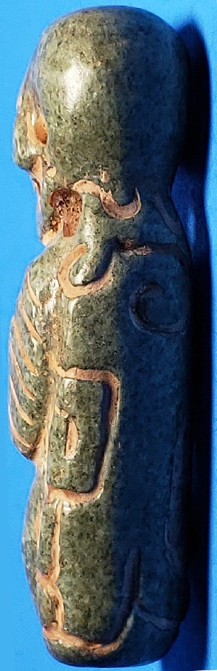

Mixtec-Xipe Totec-Jade-Classic Period-700-900 CE

**Case no.:**

**Accession Number:**

**Formal Label:**

**Display Description:**

This maskette represents **Xipe Totec as a** [life and death-rebirth deity](https://en.wikipedia.org/wiki/Life-death-rebirth_deity), a religious [motif](https://en.wikipedia.org/wiki/Motif_(folkloristics)) in which a god or goddess dies and is [resurrected](https://en.wikipedia.org/wiki/Resurrected).[[1]](https://en.wikipedia.org/wiki/Dying-and-rising_deity#cite_note-LeemingG-1)[[2]](https://en.wikipedia.org/wiki/Dying-and-rising_deity#cite_note-2)[[3]](https://en.wikipedia.org/wiki/Dying-and-rising_deity#cite_note-3)[[4]](https://en.wikipedia.org/wiki/Dying-and-rising_deity#cite_note-Miles_2009,_193-4) "[Death or departure of the gods](https://en.wikipedia.org/wiki/Death_or_departure_of_the_gods)" is motif A192 in [Stith Thompson's](https://en.wikipedia.org/wiki/Stith_Thompson) [*Motif-Index of Folk-Literature*](https://en.wikipedia.org/wiki/Motif_(folkloristics)#Thompson’s_Motif-Index), while "resurrection of gods" is motif A193.[[5]](https://en.wikipedia.org/wiki/Dying-and-rising_deity#cite_note-Thompson-5)

In [Aztec mythology](https://en.wikipedia.org/wiki/Aztec_mythology) and religion, **Xipe Totec** ([/ˈʃiːpə ˈtoʊtɛk/](https://en.wikipedia.org/wiki/Help:IPA/English); [Classical Nahuatl](https://en.wikipedia.org/wiki/Classical_Nahuatl_language): *Xīpe Totēuc* [[ˈʃiːpe ˈtoteːkʷ]](https://en.wikipedia.org/wiki/Help:IPA/Nahuatl)) or Xipetotec[[1]](https://en.wikipedia.org/wiki/Xipe_Totec" \l "cite_note-1) Robelo, Cecilio Agustín (1905). Diccionario de Mitología Nahua (in Spanish). Mexico City, Mexico: =Biblioteca Porrúa. Museo Nacional de Arqueología, Historia y Etnología. P. 768 ("Our Lord the [Flayed](https://en.wikipedia.org/wiki/Flaying) One")[[2]](https://en.wikipedia.org/wiki/Xipe_Totec#cite_note-2) Saville, Marshall (1929). "Saville 'Aztecan God Xipe Totec". Indian Notes(1929). [*Museum of the American Indian*](https://en.wikipedia.org/wiki/Museum_of_the_American_Indian): 151–174. P. 155 was a [life-death-rebirth deity](https://en.wikipedia.org/wiki/Life-death-rebirth_deity), god of [agriculture](https://en.wikipedia.org/wiki/Agriculture), [vegetation](https://en.wikipedia.org/wiki/Vegetation), the east, disease, spring, [goldsmiths](https://en.wikipedia.org/wiki/Goldsmith), [silversmiths](https://en.wikipedia.org/wiki/Silversmith), liberation and the seasons.[[3]](https://en.wikipedia.org/wiki/Xipe_Totec#cite_note-3) Fernández 1992, 1996, pp.60-63. Matos Moctezuma 1988, p.181. Matos Moctezuma & Solis Olguín 2002, pp.54-5. Neumann 1976, pp.252. *Fernández, Adela (1996) [1992]. Dioses Prehispánicos de México (in Spanish). Mexico City: Panorama Editorial.*

Various methods of human sacrifice were used to honour this god. The [flayed skins](https://en.wikipedia.org/wiki/Human_trophy_taking_in_Mesoamerica) were often taken from sacrificial victims who had their hearts cut out, and some representations of Xipe Totec show a stitched-up wound in the chest.[[38]](https://en.wikipedia.org/wiki/Xipe_Totec#cite_note-Matos_Moctezuma_2002,_p.422-38)

"Gladiator sacrifice" is the name given to the form of sacrifice in which an especially courageous war captive was given mock weapons, tied to a large circular stone and forced to fight against a fully armed [Aztec](https://en.wikipedia.org/wiki/Aztec) warrior. As a weapon he was given a *[macuahuitl](https://en.wikipedia.org/wiki/Macuahuitl" \o "Macuahuitl)* (a wooden sword with blades formed from [obsidian](https://en.wikipedia.org/wiki/Obsidian_use_in_Mesoamerica)) with the obsidian blades replaced with feathers.[[39]](https://en.wikipedia.org/wiki/Xipe_Totec#cite_note-Smith_1996,_2003,_p.218-39) A white cord was tied either around his waist or his ankle, binding him to the sacred *temalacatl* stone.[[40]](https://en.wikipedia.org/wiki/Xipe_Totec#cite_note-40) At the end of the *Tlacaxipehualiztli* festival, gladiator sacrifice (known as *tlauauaniliztli*) was carried out by five Aztec warriors; two [jaguar warriors](https://en.wikipedia.org/wiki/Jaguar_warrior), two [eagle warriors](https://en.wikipedia.org/wiki/Eagle_warrior) and a fifth, left-handed warrior.[[38]](https://en.wikipedia.org/wiki/Xipe_Totec#cite_note-Matos_Moctezuma_2002,_p.422-38)

"Arrow sacrifice" was another method used by the worshippers of Xipe Totec. The sacrificial victim was bound spread-eagled to a wooden frame, he was then shot with many arrows so that his blood spilled onto the ground.[[39]](https://en.wikipedia.org/wiki/Xipe_Totec#cite_note-Smith_1996,_2003,_p.218-39) The spilling of the victim's blood to the ground was symbolic of the desired abundant rainfall, with a hopeful result of plentiful crops.[[41]](https://en.wikipedia.org/wiki/Xipe_Totec#cite_note-41) After the victim was shot with the arrows, the heart was removed with a stone knife. The flayer then made a laceration from the lower head to the heels and removed the skin in one piece. These ceremonies went on for twenty days, meanwhile the votaries of the god wore the skins.[[42]](https://en.wikipedia.org/wiki/Xipe_Totec#cite_note-42)

Another instance of sacrifice was done by a group of metalworkers who were located in the town of [Atzcapoatzalco](https://en.wikipedia.org/wiki/Atzcapotzalco" \o "Atzcapotzalco), who held Xipe Totec in special veneration.[[43]](https://en.wikipedia.org/wiki/Xipe_Totec#cite_note-Marshall_Saville,_1929,_p.165-43) Xipe was a patron to all metalworkers (*teocuitlapizque*), but he was particularly associated with the goldsmiths.[[44]](https://en.wikipedia.org/wiki/Xipe_Totec#cite_note-44) Among this group, those who stole gold or silver were sacrificed to Xipe Totec. Before this sacrifice, the victims were taken through the streets as a warning to others.[[43]](https://en.wikipedia.org/wiki/Xipe_Totec#cite_note-Marshall_Saville,_1929,_p.165-43)

Other forms of sacrifice were sometimes used; at times the victim was cast into a firepit and burned, others had their throats cut.[[39]](https://en.wikipedia.org/wiki/Xipe_Totec#cite_note-Smith_1996,_2003,_p.218-39)

**LC Classification:**

**Date or Time Horizon:**

**Geographical Area:**

**Map:**

**GPS coordinates:**

**Cultural Affiliation:**

**Media:**

**Dimensions:** H 3 in, W ¾ in

**Weight:**

**Condition:**

**Provenance:**

**Discussion:**

Examples of gods who die and later return to life are most often cited from the [religions of the Ancient Near East](https://en.wikipedia.org/wiki/Religions_of_the_Ancient_Near_East), and traditions influenced by them including [Biblical](https://en.wikipedia.org/wiki/Hebrew_Bible) and [Greco-Roman mythology](https://en.wikipedia.org/wiki/Greco-Roman_mythology) and by extension [Christianity](https://en.wikipedia.org/wiki/Christianity). The concept of a dying-and-rising god was first proposed in [comparative mythology](https://en.wikipedia.org/wiki/Comparative_mythology) by [James Frazer's](https://en.wikipedia.org/wiki/James_Frazer) seminal [*The Golden Bough*](https://en.wikipedia.org/wiki/The_Golden_Bough). Frazer associated the motif with [fertility rites](https://en.wikipedia.org/wiki/Fertility_rite) surrounding the yearly cycle of vegetation. Frazer cited the examples of [Osiris](https://en.wikipedia.org/wiki/Osiris), [Tammuz](https://en.wikipedia.org/wiki/Tammuz_(deity)), [Adonis](https://en.wikipedia.org/wiki/Adonis) and [Attis](https://en.wikipedia.org/wiki/Attis), [Dionysus](https://en.wikipedia.org/wiki/Dionysus) and [Jesus Christ](https://en.wikipedia.org/wiki/Jesus_Christ_in_comparative_mythology).[[6]](https://en.wikipedia.org/wiki/Dying-and-rising_deity#cite_note-6)

Frazer's interpretation of the category has been critically discussed in 20th-century scholarship,[[7]](https://en.wikipedia.org/wiki/Dying-and-rising_deity#cite_note-7) to the conclusion that many examples from the world's mythologies included under "dying and rising" should only be considered "dying" but not "rising", and that the genuine dying-and-rising god is a characteristic feature of Ancient Near Eastern mythologies and the derived [mystery cults](https://en.wikipedia.org/wiki/Mystery_cult) of [Late Antiquity](https://en.wikipedia.org/wiki/Late_Antiquity).[[8]](https://en.wikipedia.org/wiki/Dying-and-rising_deity#cite_note-Gary19f-8)

The [motif](https://en.wikipedia.org/wiki/Motif_(folkloristics)) of a dying deity appears within the [mythology](https://en.wikipedia.org/wiki/Mythology) of diverse cultures – perhaps because attributes of deities were derived from everyday experiences, and the ensuing conflicts often included death.[[9]](https://en.wikipedia.org/wiki/Dying-and-rising_deity#cite_note-Bailey-9) [[10]](https://en.wikipedia.org/wiki/Dying-and-rising_deity#cite_note-Garry-10)[[11]](https://en.wikipedia.org/wiki/Dying-and-rising_deity#cite_note-Lorena-11) These examples range from [Baldr](https://en.wikipedia.org/wiki/Baldr) in [Norse](https://en.wikipedia.org/wiki/Norse_mythology) mythology to the feathered serpent [Quetzalcoatl](https://en.wikipedia.org/wiki/Quetzalcoatl) in [Aztec](https://en.wikipedia.org/wiki/Aztec) mythology. Garry, Jane; M El-Shamy, Hasan (December 1, 2004). Archetypes and Motifs in Folklore and Literature; a handbook. pp. 19–20.

Xipe Totec was also known by various other names, including **Tlatlauhca** (Nahuatl pronunciation: [[t͡ɬaˈt͡ɬawʔka]](https://en.wikipedia.org/wiki/Help:IPA/Nahuatl)), **Tlatlauhqui Tezcatlipoca** (Nahuatl pronunciation: [[t͡ɬaˈt͡ɬawʔki teskat͡ɬiˈpoːka]](https://en.wikipedia.org/wiki/Help:IPA/Nahuatl)) ("Red Smoking Mirror") and **Youalahuan** (Nahuatl pronunciation: [[jowaˈlawan]](https://en.wikipedia.org/wiki/Help:IPA/Nahuatl)) ("the Night Drinker").[[4]](https://en.wikipedia.org/wiki/Xipe_Totec#cite_note-4) The [Tlaxcaltecs](https://en.wikipedia.org/wiki/Tlaxcaltec) and the Huexotzincas worshipped a version of the deity under the name of [Camaxtli](https://en.wikipedia.org/wiki/Camaxtli),[[5]](https://en.wikipedia.org/wiki/Xipe_Totec#cite_note-5) and the god has been identified with [Yopi](https://en.wikipedia.org/w/index.php?title=Yopi_(Zapotec_god)&action=edit&redlink=1), a [Zapotec](https://en.wikipedia.org/wiki/Zapotec_civilization) god represented on [Classic Period](https://en.wikipedia.org/wiki/Mesoamerican_chronology) urns.[[6]](https://en.wikipedia.org/wiki/Xipe_Totec#cite_note-Miller_&_Taube_1993,_2003,_p.188-6) The female equivalent of Xipe Totec was the goddess Xilonen-[Chicomecoatl](https://en.wikipedia.org/wiki/Chicomecoatl).[[7]](https://en.wikipedia.org/wiki/Xipe_Totec#cite_note-7) According to Bernardino de Sahagún, Xipe Totec has a strong relation to diseases such as smallpox, blisters and eye sickness and if someone suffered from these diseases offerings were made to him.[[8]](https://en.wikipedia.org/wiki/Xipe_Totec#cite_note-8) Xipe Totec connected agricultural renewal with warfare.[[9]](https://en.wikipedia.org/wiki/Xipe_Totec#cite_note-9) He flayed himself to give food to humanity, symbolic of the way [maize](https://en.wikipedia.org/wiki/Maize) seeds lose their outer layer before [germination](https://en.wikipedia.org/wiki/Germination) and of snakes shedding their skin. Without his skin, he was depicted as a golden god. Xipe Totec was believed by the [Aztecs](https://en.wikipedia.org/wiki/Aztec) to be the god that invented war.[[10]](https://en.wikipedia.org/wiki/Xipe_Totec#cite_note-10)

* 1. Robelo 1905, p. 768.
  2. [**Jump up^**](https://en.wikipedia.org/wiki/Xipe_Totec#cite_ref-2) Marshall Saville, 1929, p. 155.
  3. [**Jump up^**](https://en.wikipedia.org/wiki/Xipe_Totec#cite_ref-3) Fernández 1992, 1996, pp.60-63. Matos Moctezuma 1988, p.181. Matos Moctezuma & Solis Olguín 2002, pp.54-5. Neumann 1976, pp.252.
  4. [**Jump up^**](https://en.wikipedia.org/wiki/Xipe_Totec#cite_ref-4) Fernández 1992, 1996, p.60. Neumann 1976, p.255.
  5. [**Jump up^**](https://en.wikipedia.org/wiki/Xipe_Totec#cite_ref-5) Fernández 1992, 1996, p.60-1.
  6. ^ [Jump up to:***a***](https://en.wikipedia.org/wiki/Xipe_Totec#cite_ref-Miller_&_Taube_1993,_2003,_p.188_6-0) [***b***](https://en.wikipedia.org/wiki/Xipe_Totec#cite_ref-Miller_&_Taube_1993,_2003,_p.188_6-1) [***c***](https://en.wikipedia.org/wiki/Xipe_Totec#cite_ref-Miller_&_Taube_1993,_2003,_p.188_6-2) [***d***](https://en.wikipedia.org/wiki/Xipe_Totec#cite_ref-Miller_&_Taube_1993,_2003,_p.188_6-3) [***e***](https://en.wikipedia.org/wiki/Xipe_Totec#cite_ref-Miller_&_Taube_1993,_2003,_p.188_6-4) [***f***](https://en.wikipedia.org/wiki/Xipe_Totec#cite_ref-Miller_&_Taube_1993,_2003,_p.188_6-5) [***g***](https://en.wikipedia.org/wiki/Xipe_Totec#cite_ref-Miller_&_Taube_1993,_2003,_p.188_6-6) Miller & Taube 1993, 2003, p.188.
  7. [**Jump up^**](https://en.wikipedia.org/wiki/Xipe_Totec#cite_ref-7) Matos Moctezuma & Solis Olguín 2002, p.426.
  8. [**Jump up^**](https://en.wikipedia.org/wiki/Xipe_Totec#cite_ref-8) O., Anderson, Arthur J.; E., Dibble, Charles (1970-01-01). [*General history of the things of New Spain : Book I, the Gods*](https://www.worldcat.org/oclc/877854386). School of American Research. [*ISBN*](https://en.wikipedia.org/wiki/International_Standard_Book_Number) [*9780874800005*](https://en.wikipedia.org/wiki/Special:BookSources/9780874800005). [*OCLC*](https://en.wikipedia.org/wiki/OCLC) [*877854386*](https://www.worldcat.org/oclc/877854386).
  9. [**Jump up^**](https://en.wikipedia.org/wiki/Xipe_Totec#cite_ref-9) Evans and Webster 2001, p. 107.
  10. [**Jump up^**](https://en.wikipedia.org/wiki/Xipe_Totec#cite_ref-10) Matos Moctezuma & Solis Olguín 2002, p.423.
  11. [**Jump up^**](https://en.wikipedia.org/wiki/Xipe_Totec#cite_ref-11) Toby Evans & David Webster, 2001, p.107
  12. [**Jump up^**](https://en.wikipedia.org/wiki/Xipe_Totec#cite_ref-EvansWebster2013_12-0) Susan Toby Evans; David L. Webster (11 September 2013). [*Archaeology of Ancient Mexico and Central America: An Encyclopedia*](https://books.google.com/books?id=vZ3DAAAAQBAJ). Taylor & Francis. p. 218. [*ISBN*](https://en.wikipedia.org/wiki/International_Standard_Book_Number) [*978-1-136-80185-3*](https://en.wikipedia.org/wiki/Special:BookSources/978-1-136-80185-3).
  13. [**Jump up^**](https://en.wikipedia.org/wiki/Xipe_Totec#cite_ref-13) <http://www.ancient.eu/Xipe_Totec/>
  14. [**Jump up^**](https://en.wikipedia.org/wiki/Xipe_Totec#cite_ref-CurranDaniels2007_14-0) Bob Curran; Ian Daniels (2007). [*Walking with the Green Man: Father of the Forest, Spirit of Nature*](https://books.google.com/books?id=mRAYt2Q6CcIC). Career Press. p. 148. [*ISBN*](https://en.wikipedia.org/wiki/International_Standard_Book_Number) [*978-1-56414-931-2*](https://en.wikipedia.org/wiki/Special:BookSources/978-1-56414-931-2).
  15. [**Jump up^**](https://en.wikipedia.org/wiki/Xipe_Totec#cite_ref-15) Fernández 1992, 1996, p.60.
  16. [**Jump up^**](https://en.wikipedia.org/wiki/Xipe_Totec#cite_ref-16) Milbrath & Peraza Lope 2003, pp.19, 23, 26.
  17. [**Jump up^**](https://en.wikipedia.org/wiki/Xipe_Totec#cite_ref-17) Museo de América.
  18. [**Jump up^**](https://en.wikipedia.org/wiki/Xipe_Totec#cite_ref-18) Marshall Saville, 1929, p.155.
  19. ^ [Jump up to:***a***](https://en.wikipedia.org/wiki/Xipe_Totec#cite_ref-Fernandezp60Moctp422_19-0) [***b***](https://en.wikipedia.org/wiki/Xipe_Totec#cite_ref-Fernandezp60Moctp422_19-1) Fernández 1992, 1996, p.60. Matos Moctezuma & Solis Olguín 2002, p.422.
  20. ^ [Jump up to:***a***](https://en.wikipedia.org/wiki/Xipe_Totec#cite_ref-Marshall_H._Saville_1929,_p.156_20-0) [***b***](https://en.wikipedia.org/wiki/Xipe_Totec#cite_ref-Marshall_H._Saville_1929,_p.156_20-1) Marshall H. Saville 1929, p.156.
  21. [**Jump up^**](https://en.wikipedia.org/wiki/Xipe_Totec#cite_ref-21) Matos Moctezuma & Solis Olguín 2002, p.468.
  22. [**Jump up^**](https://en.wikipedia.org/wiki/Xipe_Totec#cite_ref-22) Matos Moctezuma & Solis Olguín 2002, p.171.
  23. [**Jump up^**](https://en.wikipedia.org/wiki/Xipe_Totec#cite_ref-23) Marshall H. Saville 1929, p.155.
  24. ^ [Jump up to:***a***](https://en.wikipedia.org/wiki/Xipe_Totec#cite_ref-Fern%C3%A1ndez_1992,_1996,_p.62_24-0) [***b***](https://en.wikipedia.org/wiki/Xipe_Totec#cite_ref-Fern%C3%A1ndez_1992,_1996,_p.62_24-1) Fernández 1992, 1996, p.62.
  25. [**Jump up^**](https://en.wikipedia.org/wiki/Xipe_Totec#cite_ref-25) Michael D. Coe & Rex Koontz 1962, 1977, 1984, 1994, 2002, 2008, p.207.
  26. [**Jump up^**](https://en.wikipedia.org/wiki/Xipe_Totec#cite_ref-26) Matos Moctezuma & Solis Olguín 2002, p.324
  27. [**Jump up^**](https://en.wikipedia.org/wiki/Xipe_Totec#cite_ref-27) Matos Moctezuma 1988, p.188.
  28. [**Jump up^**](https://en.wikipedia.org/wiki/Xipe_Totec#cite_ref-28) Marshall Saville, p. 167.
  29. [**Jump up^**](https://en.wikipedia.org/wiki/Xipe_Totec#cite_ref-29) Matos Moctezuma & Solis Olguín 2002, pp.422, 468. Smith 1996, 2003, p.252.
  30. [**Jump up^**](https://en.wikipedia.org/wiki/Xipe_Totec#cite_ref-30) Marshall Saville, 1929, p. 171.
  31. [**Jump up^**](https://en.wikipedia.org/wiki/Xipe_Totec#cite_ref-31) Franke J. Neumann 1976, p. 254. Matos Moctezuma & Solis Olguín 2002, p.422. Miller & Taube 1993, 2003, p.188.
  32. [**Jump up^**](https://en.wikipedia.org/wiki/Xipe_Totec#cite_ref-32) Marshall Saville, 1929, p. 167-168.
  33. ^ [Jump up to:***a***](https://en.wikipedia.org/wiki/Xipe_Totec#cite_ref-Matos_Moctezuma_p.422_33-0) [***b***](https://en.wikipedia.org/wiki/Xipe_Totec#cite_ref-Matos_Moctezuma_p.422_33-1) Matos Moctezuma & Solis Olguín 2002, p.422
  34. [**Jump up^**](https://en.wikipedia.org/wiki/Xipe_Totec#cite_ref-34) Franke J. Neumann 1976, p. 254.
  35. [**Jump up^**](https://en.wikipedia.org/wiki/Xipe_Totec#cite_ref-35) Matos Moctezuma & Solis Olguín 2002, p.478
  36. [**Jump up^**](https://en.wikipedia.org/wiki/Xipe_Totec#cite_ref-36) Matos Moctezuma & Solis Olguín 2002, p.423
  37. [**Jump up^**](https://en.wikipedia.org/wiki/Xipe_Totec#cite_ref-37) Marshall Saville, 1929, p. 169-170.
  38. ^ [Jump up to:***a***](https://en.wikipedia.org/wiki/Xipe_Totec#cite_ref-Matos_Moctezuma_2002,_p.422_38-0) [***b***](https://en.wikipedia.org/wiki/Xipe_Totec#cite_ref-Matos_Moctezuma_2002,_p.422_38-1) Matos Moctezuma & Solis Olguín 2002, p.422.
  39. ^ [Jump up to:***a***](https://en.wikipedia.org/wiki/Xipe_Totec#cite_ref-Smith_1996,_2003,_p.218_39-0) [***b***](https://en.wikipedia.org/wiki/Xipe_Totec#cite_ref-Smith_1996,_2003,_p.218_39-1) [***c***](https://en.wikipedia.org/wiki/Xipe_Totec#cite_ref-Smith_1996,_2003,_p.218_39-2) Smith 1996, 2003, p.218.
  40. [**Jump up^**](https://en.wikipedia.org/wiki/Xipe_Totec#cite_ref-40) Matos Moctezuma & Solis Olguín 2002, p.451-2.
  41. [**Jump up^**](https://en.wikipedia.org/wiki/Xipe_Totec#cite_ref-41) Marshall Saville, 1929, p.164.
  42. [**Jump up^**](https://en.wikipedia.org/wiki/Xipe_Totec#cite_ref-42) Marshall Saville, 1929, p.173-174.
  43. ^ [Jump up to:***a***](https://en.wikipedia.org/wiki/Xipe_Totec#cite_ref-Marshall_Saville,_1929,_p.165_43-0) [***b***](https://en.wikipedia.org/wiki/Xipe_Totec#cite_ref-Marshall_Saville,_1929,_p.165_43-1) Marshall Saville, 1929, p.165.
  44. [**Jump up^**](https://en.wikipedia.org/wiki/Xipe_Totec#cite_ref-44) Franke J. Neumann 1976, p. 255.

## References[[edit](https://en.wikipedia.org/w/index.php?title=Xipe_Totec&action=edit&section=7)]

|  |  |
| --- | --- |
| https://upload.wikimedia.org/wikipedia/en/thumb/4/4a/Commons-logo.svg/30px-Commons-logo.svg.png | Wikimedia Commons has media related to ***[Xipe Totec](https://commons.wikimedia.org/wiki/Category:Xipe_Totec" \o "commons:Category:Xipe Totec)***. |

[*Coe, Michael D.*](https://en.wikipedia.org/wiki/Michael_D._Coe); [*Rex Koontz*](https://en.wikipedia.org/w/index.php?title=Rex_Koontz&action=edit&redlink=1) (2008) [1962]. Mexico From the Olmecs to the Aztecs. New York, New York: [*Thames & Hudson*](https://en.wikipedia.org/wiki/Thames_%26_Hudson). [*ISBN*](https://en.wikipedia.org/wiki/International_Standard_Book_Number) [*978-0-500-28755-2*](https://en.wikipedia.org/wiki/Special:BookSources/978-0-500-28755-2). [*OCLC*](https://en.wikipedia.org/wiki/OCLC) [*2008901003*](https://www.worldcat.org/oclc/2008901003).

Evans, Toby & Webster, David (2001). Archaeology of Ancient Mexico and Central American Encyclopedia. New York: [*Garland Publishing*](https://en.wikipedia.org/wiki/Garland_Publishing). [*ISBN*](https://en.wikipedia.org/wiki/International_Standard_Book_Number) [*0-8153-0887-6*](https://en.wikipedia.org/wiki/Special:BookSources/0-8153-0887-6).

Fernández, Adela (1996) [1992]. Dioses Prehispánicos de México (in Spanish). Mexico City: Panorama Editorial. [*ISBN*](https://en.wikipedia.org/wiki/International_Standard_Book_Number) [*968-38-0306-7*](https://en.wikipedia.org/wiki/Special:BookSources/968-38-0306-7). [*OCLC*](https://en.wikipedia.org/wiki/OCLC) [*59601185*](https://www.worldcat.org/oclc/59601185).

[*Matos Moctezuma, Eduardo*](https://en.wikipedia.org/wiki/Eduardo_Matos_Moctezuma) (1988). The Great Temple of the Aztecs: Treasures of Tenochtitlan. New Aspects of Antiquity series. [*Doris Heyden*](https://en.wikipedia.org/wiki/Doris_Heyden) (trans.). London: [*Thames & Hudson*](https://en.wikipedia.org/wiki/Thames_%26_Hudson). [*ISBN*](https://en.wikipedia.org/wiki/International_Standard_Book_Number) [*0-500-27752-4*](https://en.wikipedia.org/wiki/Special:BookSources/0-500-27752-4). [*OCLC*](https://en.wikipedia.org/wiki/OCLC) [*17968786*](https://www.worldcat.org/oclc/17968786).

[*Matos Moctezuma, Eduardo*](https://en.wikipedia.org/wiki/Eduardo_Matos_Moctezuma); [*Felipe Solis Olguín*](https://en.wikipedia.org/wiki/Felipe_Solis_Olgu%C3%ADn) (2002). Aztecs. London: [*Royal Academy of Arts*](https://en.wikipedia.org/wiki/Royal_Academy_of_Arts). [*ISBN*](https://en.wikipedia.org/wiki/International_Standard_Book_Number) [*1-903973-22-8*](https://en.wikipedia.org/wiki/Special:BookSources/1-903973-22-8). [*OCLC*](https://en.wikipedia.org/wiki/OCLC) [*56096386*](https://www.worldcat.org/oclc/56096386).

Milbrath, Susan; Carlos Peraza Lopez (2003). "Revisiting Mayapan: Mexico's last Maya capital". Ancient Mesoamerica. [*Cambridge University Press*](https://en.wikipedia.org/wiki/Cambridge_University_Press). **14**: 1–46. [*doi*](https://en.wikipedia.org/wiki/Digital_object_identifier):[*10.1017/s0956536103132178*](https://doi.org/10.1017%2Fs0956536103132178).

[*Miller, Mary*](https://en.wikipedia.org/wiki/Mary_Miller_(art_historian)); [*Karl Taube*](https://en.wikipedia.org/wiki/Karl_Taube) (2003) [1993]. An Illustrated Dictionary of the Gods and Symbols of Ancient Mexico and the Maya. London: [*Thames & Hudson*](https://en.wikipedia.org/wiki/Thames_%26_Hudson). [*ISBN*](https://en.wikipedia.org/wiki/International_Standard_Book_Number) [*0-500-27928-4*](https://en.wikipedia.org/wiki/Special:BookSources/0-500-27928-4). [*OCLC*](https://en.wikipedia.org/wiki/OCLC) [*28801551*](https://www.worldcat.org/oclc/28801551).

Museo de América. [*"Museo de América (Catalogue - item 1991/11/48)"*](http://ceres.mcu.es/pages/Main) (in Spanish). Madrid, Spain: Ministerio de Educación, Cultura y Deporte*. Retrieved 2012-06-15*.

Neumann, Franke J. (February 1976). "The Flayed God and His Rattle-Stick: A Shamanic Element in Pre-Hispanic Mesoamerican Religion". History of Religions. Chicago, IL: [*University of Chicago Press*](https://en.wikipedia.org/wiki/University_of_Chicago_Press). **15** (3): 251–263. [*doi*](https://en.wikipedia.org/wiki/Digital_object_identifier):[*10.1086/462746*](https://doi.org/10.1086%2F462746).

Robelo, Cecilio Agustín (1905). Diccionario de Mitología Nahua (in Spanish). Mexico City, Mexico: =Biblioteca Porrúa. Museo Nacional de Arqueología, Historia y Etnología. [*ISBN*](https://en.wikipedia.org/wiki/International_Standard_Book_Number) [*978-9684327955*](https://en.wikipedia.org/wiki/Special:BookSources/978-9684327955).

Saville, Marshall (1929). "Saville 'Aztecan God Xipe Totec". Indian Notes(1929). [*Museum of the American Indian*](https://en.wikipedia.org/wiki/Museum_of_the_American_Indian): 151–174.

Smith, Michael E. (2003) [1996]. The Aztecs (second ed.). Malden MA; Oxford and Carlton, Australia: [*Blackwell Publishing*](https://en.wikipedia.org/wiki/Blackwell_Publishing). [*ISBN*](https://en.wikipedia.org/wiki/International_Standard_Book_Number) [*0-631-23016-5*](https://en.wikipedia.org/wiki/Special:BookSources/0-631-23016-5). [*OCLC*](https://en.wikipedia.org/wiki/OCLC) [*59452395*](https://www.worldcat.org/oclc/59452395).

## Further reading[[edit](https://en.wikipedia.org/w/index.php?title=Xipe_Totec&action=edit&section=8)]

Mencos, Elisa (2010). B. Arroyo; A. Linares; L. Paiz, eds. [*"Las representaciones de Xipe Totec en la frontera sur Mesoamericana"*](https://web.archive.org/web/20141103022601/http:/www.asociaciontikal.com/pdf/94.Mencos_09.pdf) [The Representations of Xipe Totec on the southern frontier of Mesoamerica] (PDF). XXIII Simposio de Investigaciones Arqueológicas en Guatemala, 2009 (in Spanish). Guatemala City: Museo Nacional de Arqueología y Etnología: 1259–1266. Archived from [*the original*](http://www.asociaciontikal.com/pdf/94.Mencos_09.pdf) (PDF) on 2014-11-03*. Retrieved 2012-07-07*.

[*Pareyon, Gabriel*](https://en.wikipedia.org/wiki/Gabriel_Pareyon) (2006). [*"La música en la fiesta del dios Xipe Totec"*](https://web.archive.org/web/20110720185539/https:/tuhat.halvi.helsinki.fi/portal/files/13129031/Xipe_Totec.pdf) (PDF). Proceedings of the 3rd National Forum of Mexican Music, 3 (2007) (in Spanish). Universidad Autónoma de Zacatecas: 2–17. Archived from [*the original*](https://tuhat.halvi.helsinki.fi/portal/files/13129031/Xipe_Totec.pdf) (PDF) on July 20, 2011.

**References:**

Deimel, Claus and Elke Ruhnau, 2000. *Jaguar and Serpent: The Cosmos of Indians in Mexico, Central and South America.* Berlin: Reimer. p. 63

*New Aspects of Antiquity series.* [*Doris Heyden*](https://en.wikipedia.org/wiki/Doris_Heyden) *(trans.). London:* [*Thames & Hudson*](https://en.wikipedia.org/wiki/Thames_%26_Hudson)*.*